**Project Week 3**

**Design Proposal**

Ryan Karlovsky

Callie Houlihan

Bryce Benedict

Matt Keeley

1. Common language Prototype summaries

Van Design

The van design has the body and size of a normal van, with two outward swinging doors that open wide enough to allow a wheelchair to fit through. A ramp slides out and the passenger wheels themselves into the van manually, then the ramp will retract back under the floor via cables and the doors will close. The main selling point of this design is the ease of converting existing vans into the design.

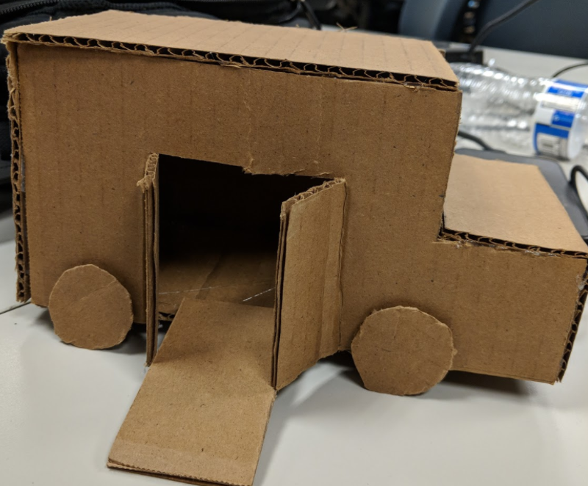

Cube Design

The cube design has a mostly square shape, only large enough for the single passenger, with a outward and upward swinging door. The lift mechanism for getting wheelchairs into the vehicle doubles as the locking mechanism to keep the wheelchair secure. The main selling point of this design is its size. There is no need to spend money on a larger vehicle, if it only needs to fit a single passenger.

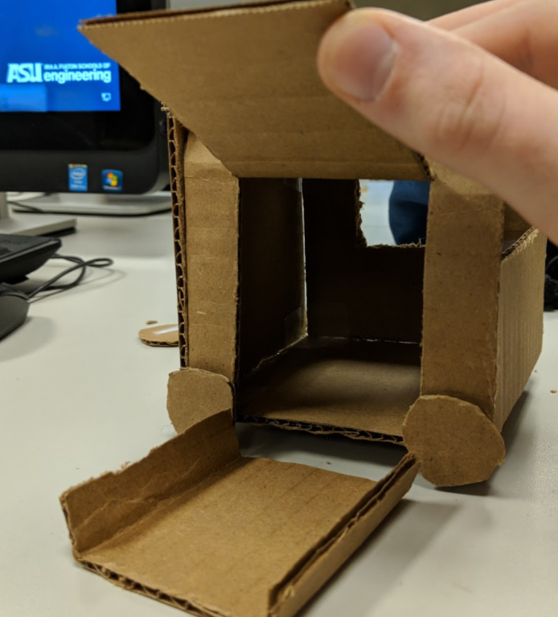

2. Detailed Design Functionality for the Chosen Vehicle

We chose the Cube as our design due to its compact and simpler design, allowing us to focus more time on the key features.

* Door
  + Opens upwards via pulling cables. Releasing tension on the cables will allow gravity to close the door after the passenger is secured.
* Shape/Size of the vehicle
  + The car dimensions will allow a single wheelchair passenger to fit. Anything larger is unnecessary and will complicate the design process, costing more money in the form of time and materials.
* Platform and Locking Mechanism
  + A platform that fits inside the dimensions of the vehicle will fit one wheelchaired passenger on it. It has parallel bars on each side that uses a hydraulics system to squeeze the sides of the wheelchair (near the floor) and keep it snug during the trip.
* Lift Mechanism
  + The platform is attached to a hydraulic lift mechanism that can move it out and back into the vehicle, stopping to allow a passenger to secure onto the platform. More research needs to be done to properly design a functioning lift mechanism.

3. Project Plan (in 30 minute chunks)

We will break into 2 teams, one focusing on the research and development of the maze solving algorithm, and another focusing on the design and build of the vehicle itself. After 15-20 hours of time, the teams will likely be in position to combine their efforts and begin testing simultaneously.

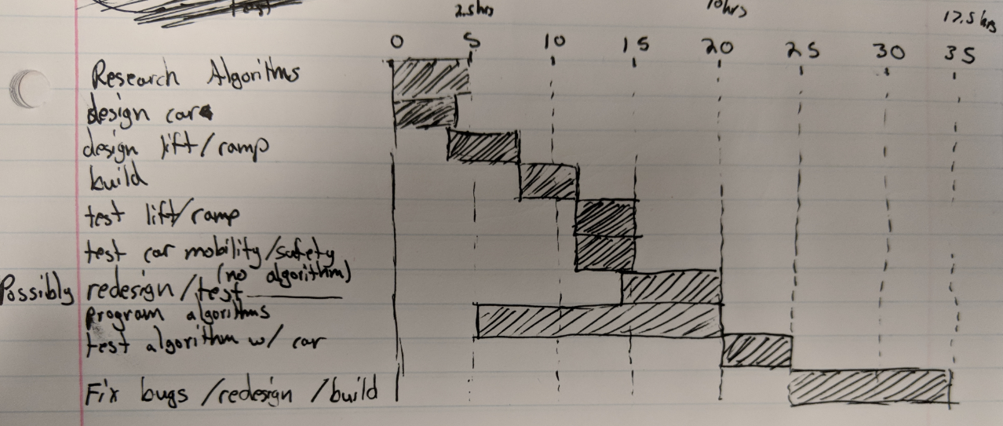

4. Feedback received

We need to digitize the Project Plan, probably using Excel or a gantt chart builder online.